2017-03-29

Bryan Greener

Chad Hirsch

Jason Gunderson

Workshop ch9

9.28

**a)**

Male Female

0.4698917 0.5301083

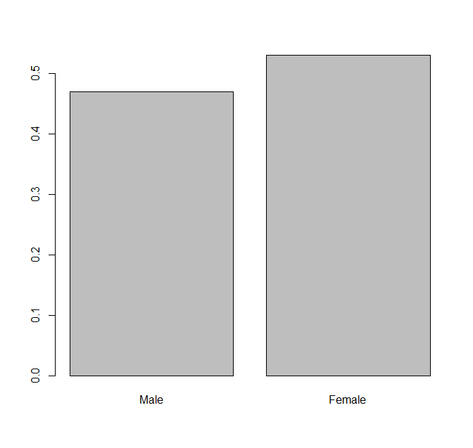

**b)**

Male:

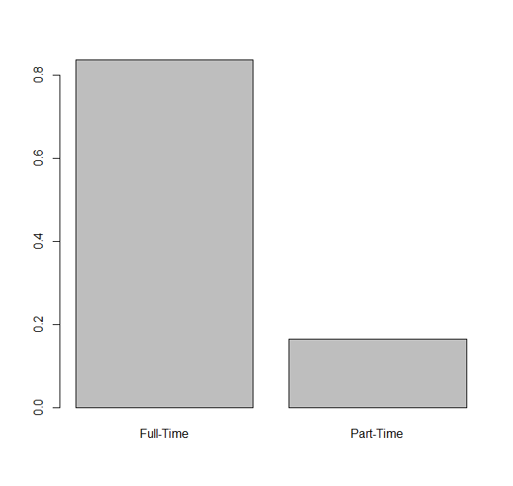

Female:

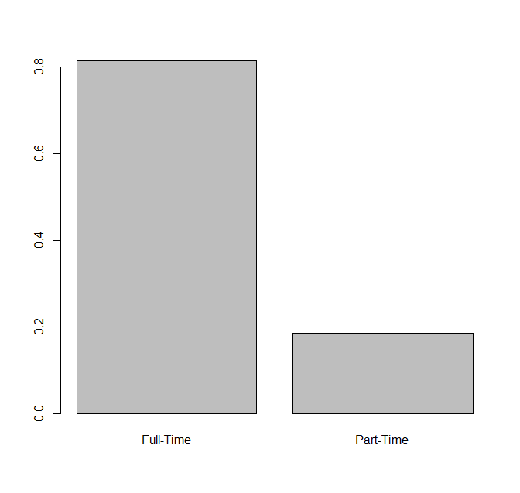

The Male and Female conditional distributions differ ever so slightly. The female is reflecting the fact that by percentage there are less full time and part time employments while male is showing that there is a higher percentage of people employed overall.

**c)**

Full-Time Male: 2683.082

Full-Time Female: 3026.918

**d)**

X-squared = 5.0269, df = 1, p-value = 0.02496

Since the pvalue is less than 0.05, we reject H0.

9.49

X-squared = 3.7807, df = 3, p-value = 0.2861

Code

data=rbind(c(2719,2991),c(535,680))

# GENERATE MARGINAL DISTRIBUTION

total=sum(data)

#row1=sum(data[1,])

#row2=sum(data[2,])

col1=sum(data[,1])

col2=sum(data[,2])

#prop.margin.row=c(row1/total,row2/total)

prop.margin.col=c(col1/total,col2/total)

names(prop.margin.col)=c("Male","Female")

#barplot(prop.margin.row)

#x11()

barplot(prop.margin.col)

prop.margin.col

# GENERATE CONDITIONAL DISTRIBUTION

prop1=data[,1]/col1

prop2=data[,2]/col2

names(prop1)=c("Full-Time","Part-Time")

names(prop2)=c("Full-Time","Part-Time")

barplot(prop1)

barplot(prop2)

# FIND EXPECTED VALUES FOR ROW 1 CELLS

expected1=(sum(data[1,])*sum(data[,1]))/total

expected1

expected2=(sum(data[1,])*sum(data[,2]))/total

expected2

# CALCULATE P-VALUE

chisq.test(data)

# 9.49

# CALCULATE CHISQ TEST

counts=c(79,83,36,12)

result=chisq.test(counts,p=c(.43,.35,.15,.07))

result